**Important Info About Travis and Account Registration**

In the upcoming lecture, we will be signing up for an account with Travis. Since travis-ci.org is no longer operational, you will be redirected to sign up at:

[**https://www.travis-ci.com/**](https://www.travis-ci.com/)

Along with this change, they have also updated their terms regarding free accounts and credits due to [crypto mining abuse](https://blog.travis-ci.com/2021-10-20-mining).

As a result, you will need to select a plan after registering:

Select Monthly Plans and then the free Trial Plan. This will give you **10,000 free credits** to use within 30 days.

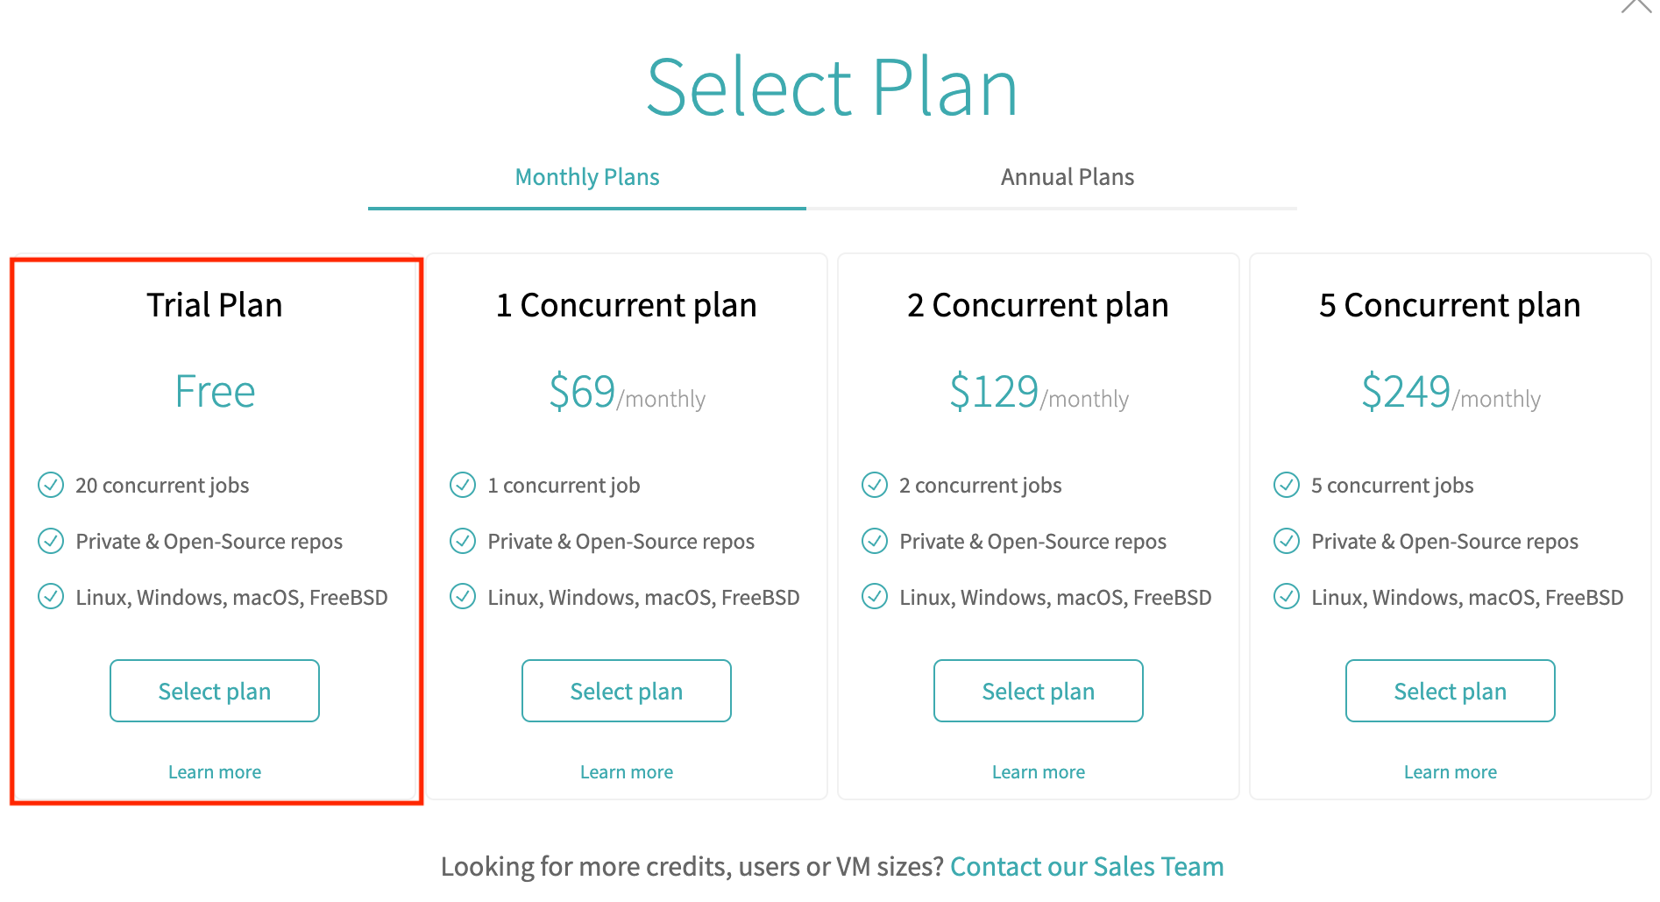

**IMPORTANT - as part of the registration process, Travis now requires adding a Credit Card.**

*A free ‘Trial’ Plan, which any new user can select upon sign up, is a usage-based plan with an unlimited amount of users, which comes with a 10k trial pool of credits to start building right away.****Once these credits run out, they are not replenished, and users must subscribe to a higher plan to continue building****. Request*[*OSS Credits allowance*](https://docs.travis-ci.com/user/billing-faq/#what-if-i-am-building-open-source)*, or please consider one of our available plans.****Trial credits are valid only for 30 days.***

<https://docs.travis-ci.com/user/billing-overview/>

**If you run out of credits, are unable to register for a Travis account, or, simply do not wish to use Travis**:

We have provided guidance to use Github Actions instead (scroll past the lecture video to see the featured question):

<https://www.udemy.com/course/docker-and-kubernetes-the-complete-guide/learn/lecture/11437142#questions/17673926>